# “Shades”

## Group members

## Harsh Mishra PRN: 20030121035

## Harshika Jadhav PRN: 20030121036

*Under the guidance of*

Dr. Amol Vibhute

## Submitted in partial fulfillment of undergraduate Degree

## Bachelor of Computer Application(BCA)

## To

## SYMBISOIS INSTITUTE OF COMPUTER STUDIES AND RESEARCH CONSTITUTENT OF SYMBSIOSIS INTERNATIONAL

## (DEEMED UNIVERSITY), PUNE

### April 2022

**Symbiosis Institute of Computer Studies and Research**

**<**Shades**>**

**Table of Content**

Acknowledgement

Declaration (refer the format provided in the file)

Certificate of Institute (refer the format provided in the file)

List of tables if applicable

List of Figures if applicable Abstract

|  |  |  |
| --- | --- | --- |
| **S.No** | **Details** | **Page No** |
| 1. Introduction | * Project profile * Existing System | 6 |
| 1. Literature Review |  | 6 |
| 1. Problem Formulation | * Objectives of Proposed System * Scope of the proposed system * Feasibility study * H/W & S/W requirements | 7 |
| 1. Proposed Methodology | * Use cases/ERD/table structure/wireframes * UI Design | 8 |
| 1. Results |  | 10 |
| 1. Test cases |  | 10 |
| 1. Further scope for development |  | 19 |
| 1. References |  | 20 |

ANNEXURES

Plagiarism Report (Title page and Originality report page)

**The report should have above format. Before submission, plagiarism check should be carried out on turnitin and it should be <=10%.** Pl fill up the AIC format and send it to mentor faculty. The mentor faculty will submit the report to AIC (in the format shared) and [bca@sicsr.ac.in](mailto:bca@sicsr.ac.in) with the main report.

The report format may change as per the project work. Variations in the report can be discussed with the mentor faculty.

**ACKNOWLEDGEMENT**

Our team has worked really hard to accomplish the project. It would not have been feasible, however, without the direction and unwavering support of a large number of individuals, including our professors. We would like to express our heartfelt thanks to each and every one of them.

We would like to express **our gratitude to Dr. Amol Vibhute** sir for his extended guidance and mentorship during the project.

We owe a debt of gratitude to Symbiosis Institute of Computer Studies and Research for their direction and continual monitoring, as well as for supplying vital project information and ongoing assistance in guaranteeing the project's completion.

**Certificate**

*This is to certify that*

Ms. Harshika Jadhav and Mr. Harsh Mishra

Has successfully completed the Project entitled

Shades

For

Semester 4

In the partial fulfillment of the

## Bachelor of Computer Application

From

Symbiosis Institute of Computer Studies & Research

Constituent of Symbiosis International (Deemed University),

Pune

Sign Sign

Dr.Priti Kulkarni

Programme In Charge- BCA

Mentor Name and Designation

# DECLARATION

I hereby declare that the dissertation/ project work entitled

“ Shades ”

Submitted to Symbiosis Institute of Computer Studies & Research (Constituent of Symbiosis International (Deemed University), Pune), under the guidance of

Dr. /Ms/ Mr. /Prof. Amol Vibhute_________

and this project work is submitted in the partial fulfillment of the requirements for the award of the degree of Bachelor of Computer Application(BCA). We the undersigned hereby declare that,

1. The work here submitted is original except for source material explicitly acknowledged.
2. The results embodied in this report have not been submitted to any other purpose/University or Institute for the award of any degree or diploma.
3. In the case of a group project, we are aware that each student is responsible and liable to disciplinary actions should there be any plagiarized contents/undeclared multiple submission in the group project, irrespective of whether he/she has signed the declaration and whether he/she has contributed directly or indirectly to the problematic contents.
4. It is also understood that assignments without a properly signed declaration by the student concerned and in the case of a group project, by all members of the group concerned, will not be graded by the teacher(s)/Mentors/Examiners.

Date: 12/04/2022

Student PRN 20030121035 Name Harsh Mishra Signature 

Student PRN 20030121036 Name Harshika Jadhav Signature 

**Introduction:**

1. Project profile

* Providing Local business opportunities.
* Increasing doorstep frames try out accessibility.

1. Existing System

* Coverage of doorstep frame try out is very low.
* There’s no option to connect with the local business.

## Literature Review

With respect to the prepared website, there is one particular website, known as “Lenskart” that sells different eyewear and does home eye tests but in a very limited quantity. With the prepared website we want to connect the consumer with the seller instead of cutting out the middleman which in return will provide greater accessibility.

Even though, the areas of digital retailing and the field of online shopping, has grown by leaps and bounds over the recent years, it can still be concluded that the impact it has had on various sectors has been poorly understood. In Spite of the fact that the issues like substitution and complementarity between various conventional and virtual retail channels have been quite extensively explored, very few attempts have actually been made to extend this work, so that it can incorporate virtual retail channels into the modeling frameworks that can actually help in integrating shopping and mobility decisions. If we look closely, people in many parts of the world are still skeptical of the products that are sold online and believe online sellers are more or less frauds. In Spite of the significant growth that the “Shares of Online Retailing”have experienced, people still disapprove of a large portion of online sellers and also are quite dissuaded towards people who want to sell their products online.

## Problem Formulation:

## Scope of Project:

We’ve made a website named Shades, we have used HTML, CSS, JavaScript SASS. It is a website for an online store for glasses, we got our inspiration from LensKart.

Shade’s aim is to help drop the prices of eyewears as well as to provide more opportunities to the local business to grow more by increasing their business.

Lenskart dropped their prices by cutting out the middleman, but in the process also cut out the rapport between the small-business and consumers. Somehow Lenskart have their own local shops.

## 

## Objective

During recent events, eyewears has become more important than ever. Since the work from home increased so did the requirement for eye care. The times are still uncertain though we’ve seen major improvements. The threat of another lockdown still lingers on us, so we came up with an idea which we’ll explore in a bit in detail but in brief we thought of an easier and more economical way of delivering eyewears to your doorsteps.

When we buy eyewears online we can’t really see them beforehand or get a feel, sure most websites have a policy of returning them but that only increases the time it will take you to select the ones you want.

Shades will allow one to select upto 7 frames and from any of the local eyewear shops, have them delivered to your doorsteps and choose the desired frames while sending the rest back.

**H/W and S/W Requirements:**

The minimum hardware and software requirements needed to run the website are:

* Operating Sytem: Windows 7
* RAM: 2GB
* Web Browsers: Internet Explorer, Microsoft Edge, Firefox, Chrome, Brave, Opera, Safari
* Software used for writing down the code: Visual Studio Code

## 

## Methodology:

## 

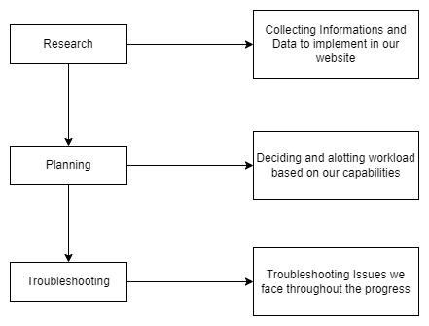

**Development**:

<index.html>

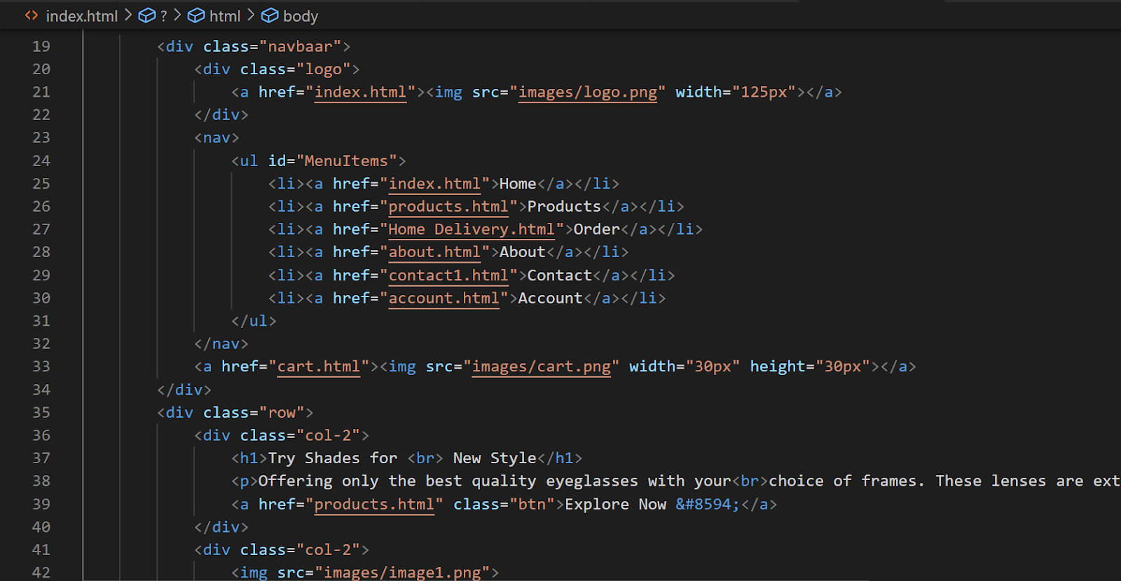

<home delivery.html?

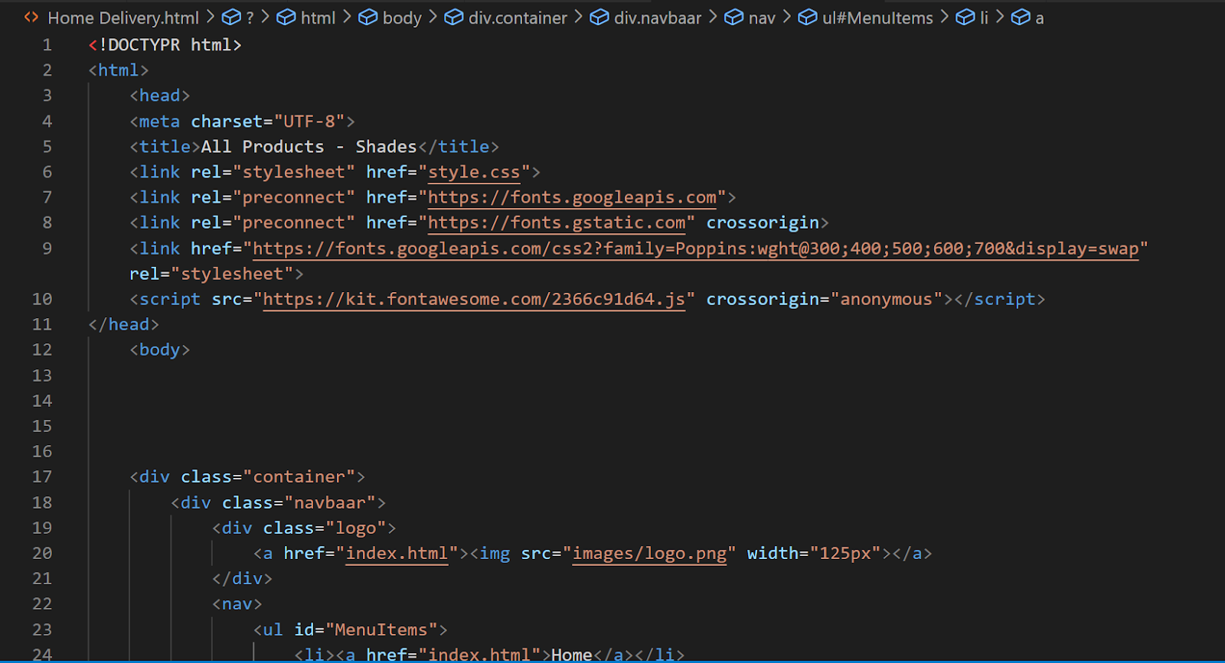

<product-detals.html>

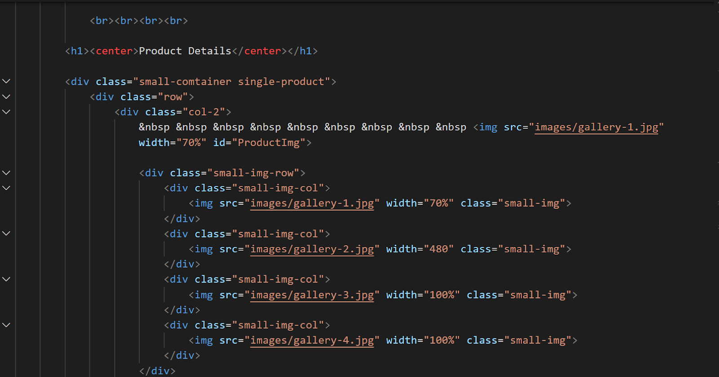

**Test case and Results:**

**(Home Page)**

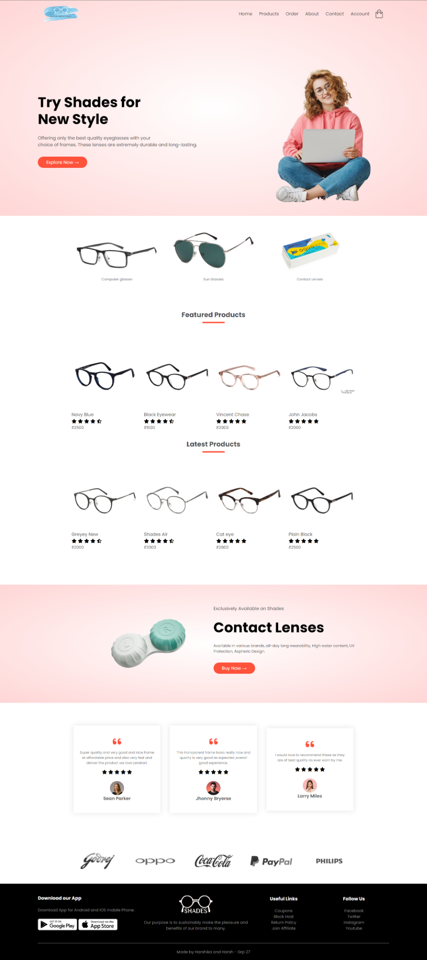



**Account Page**

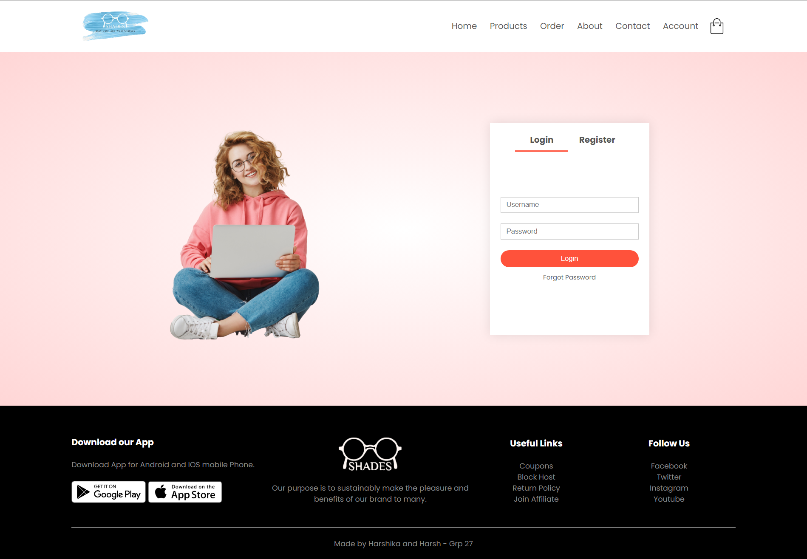

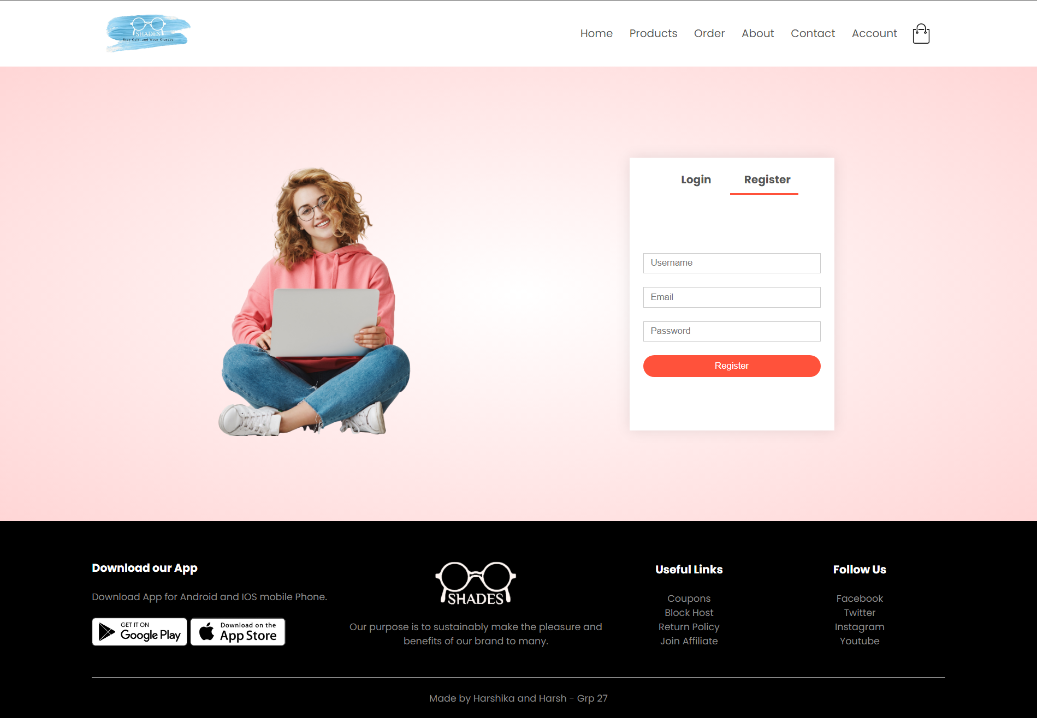

**Product’s Page**

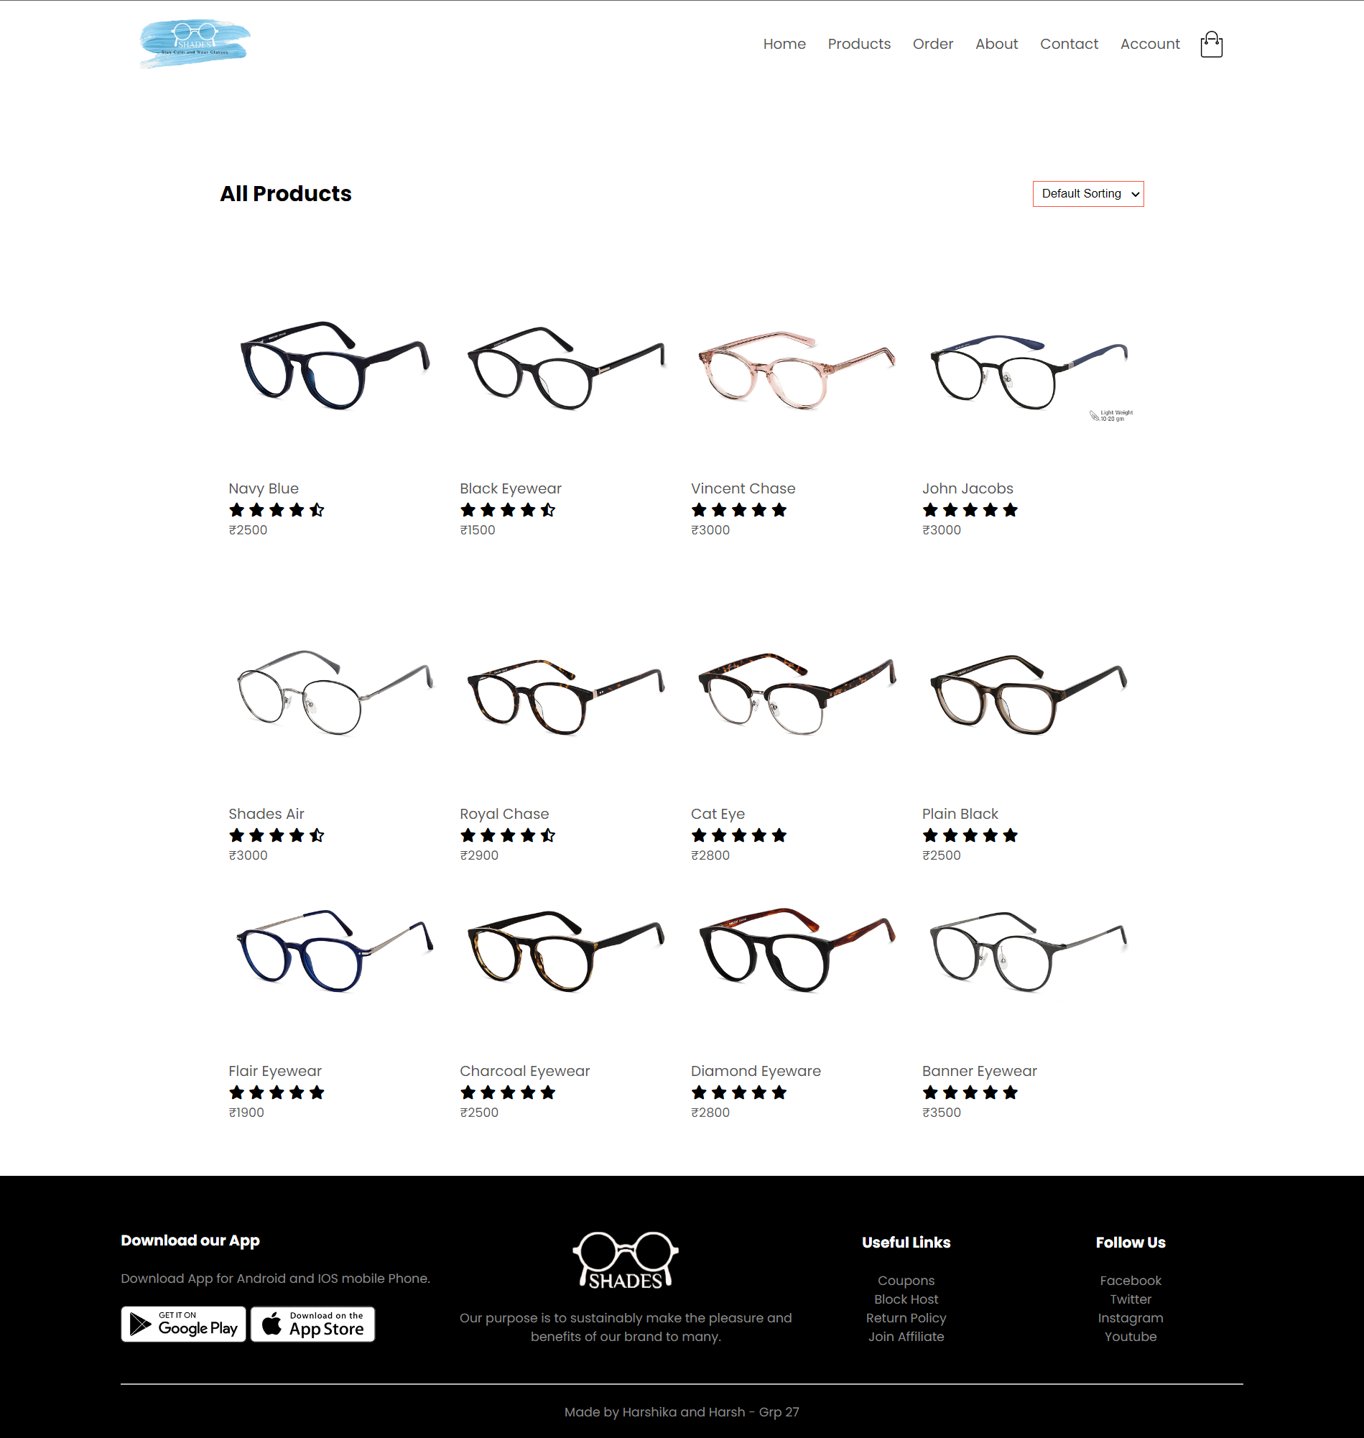

**Product Details**

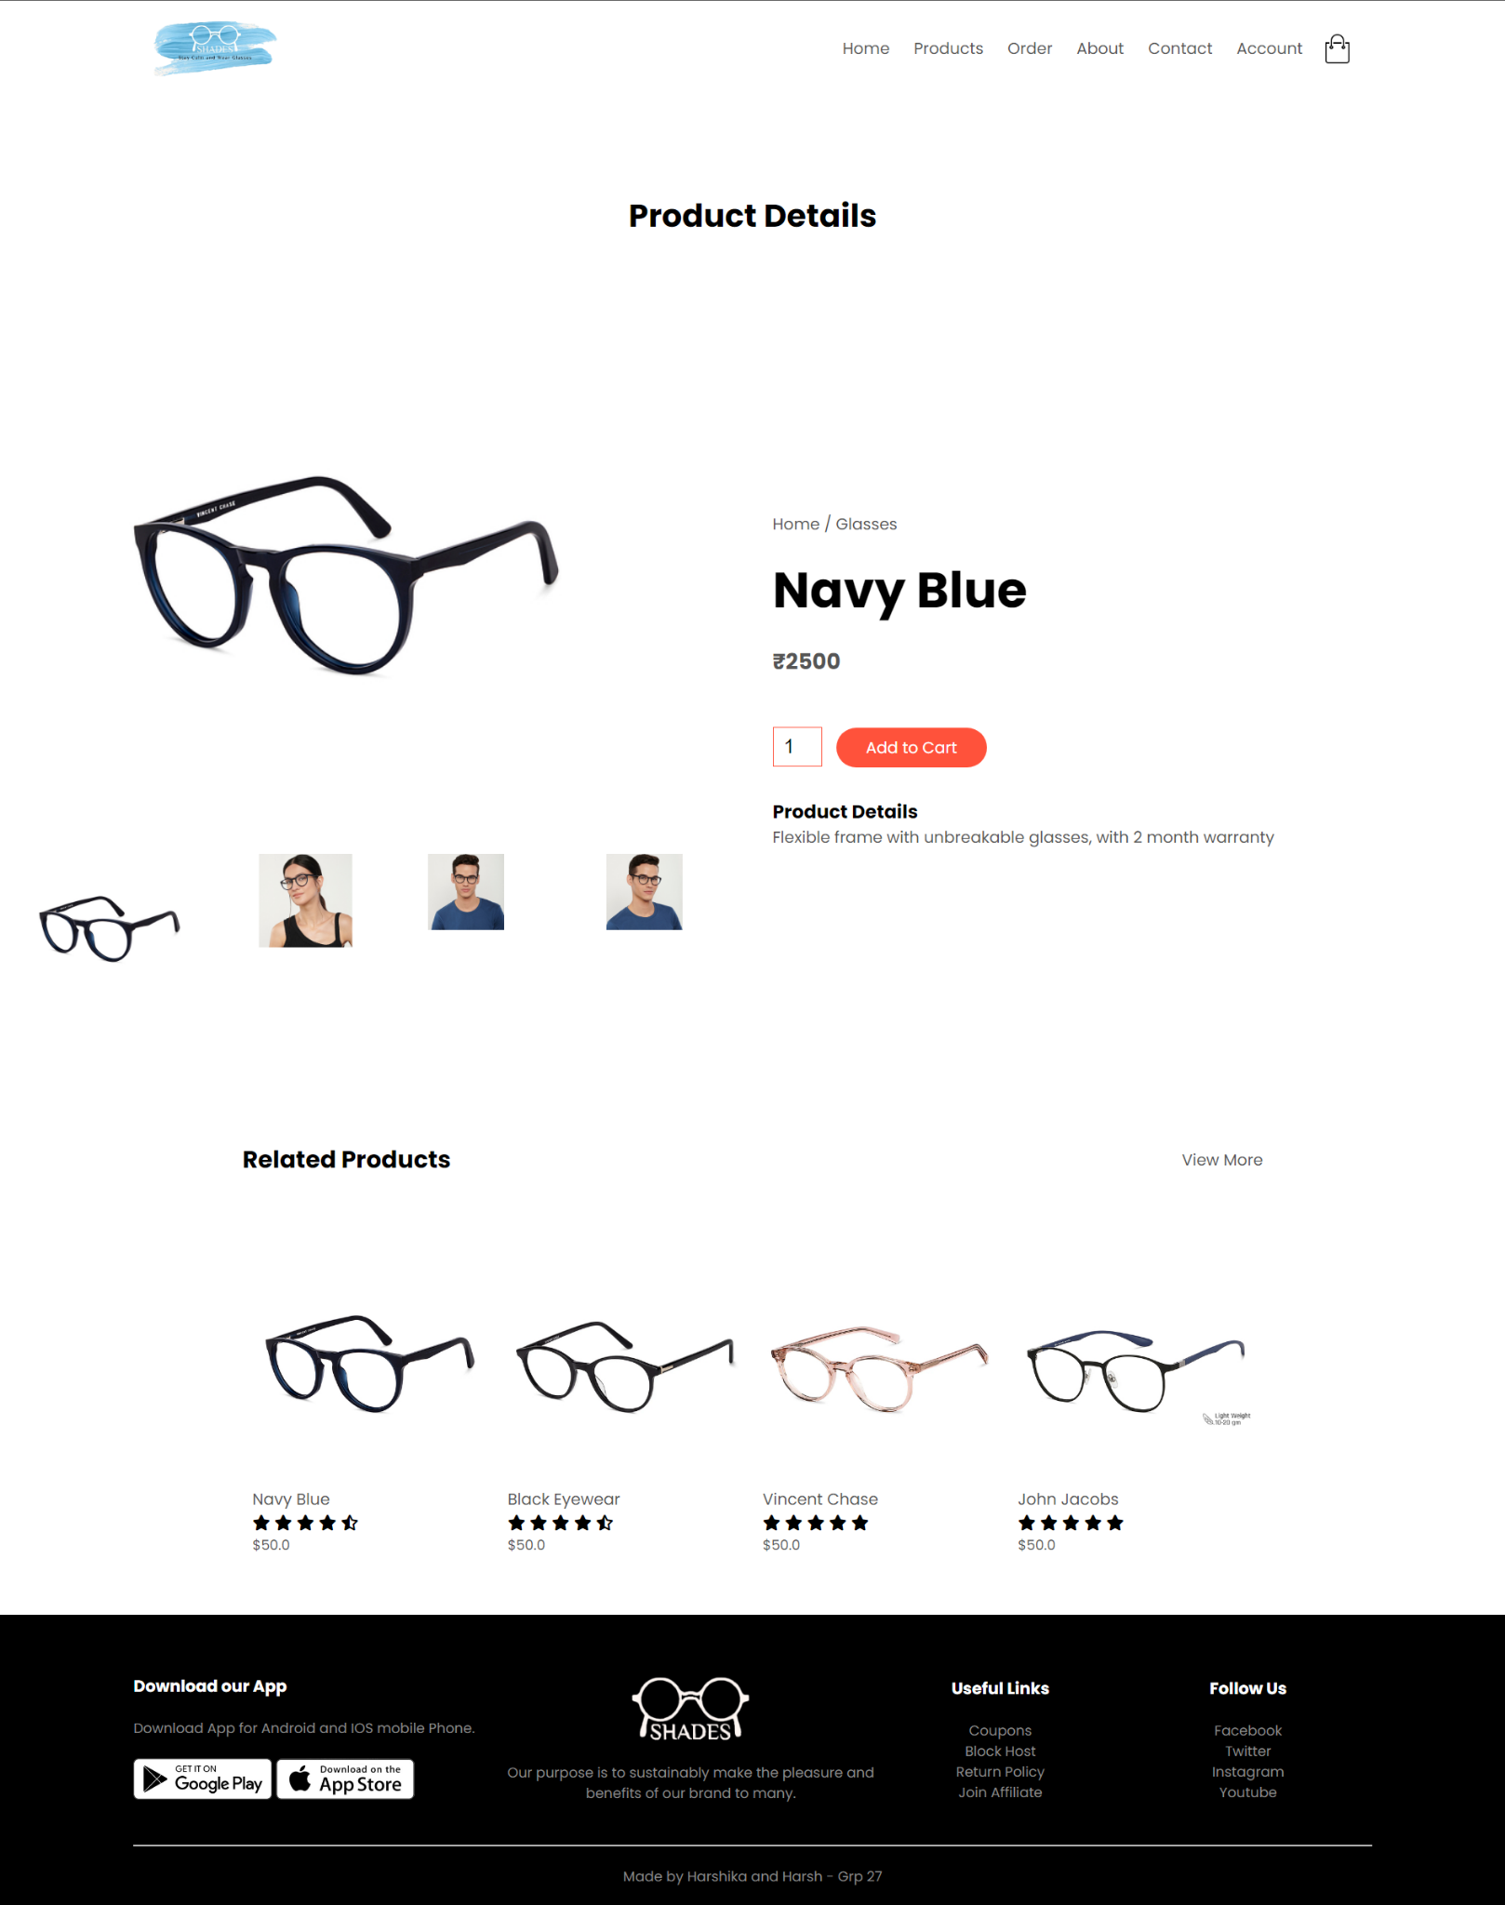

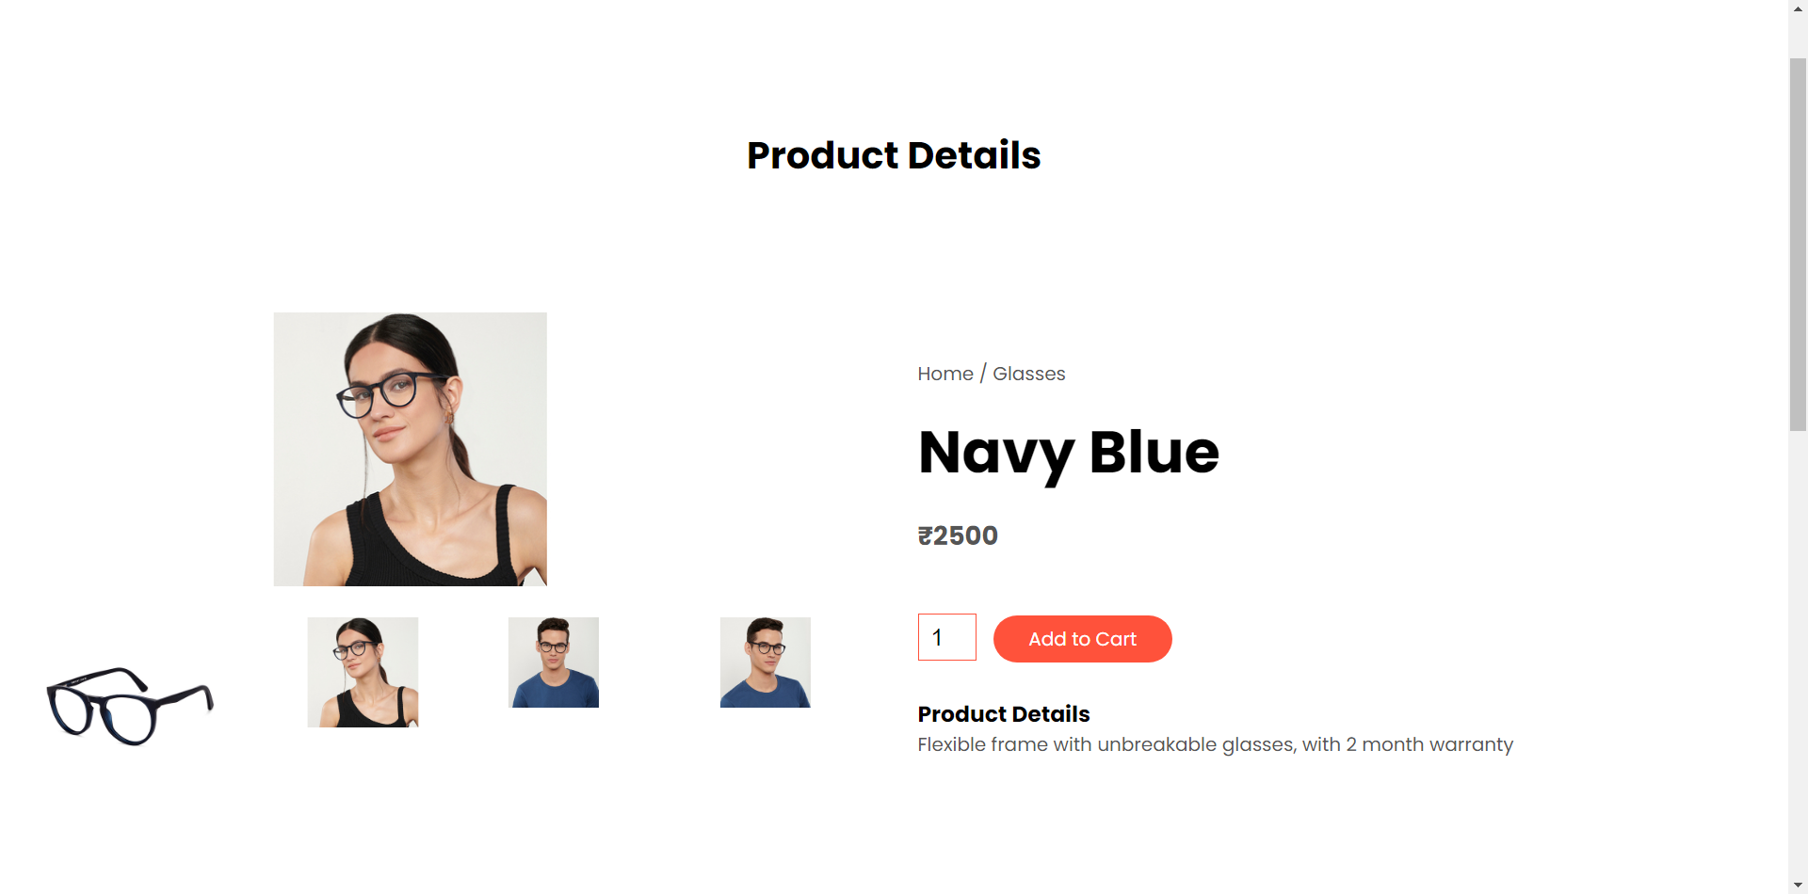

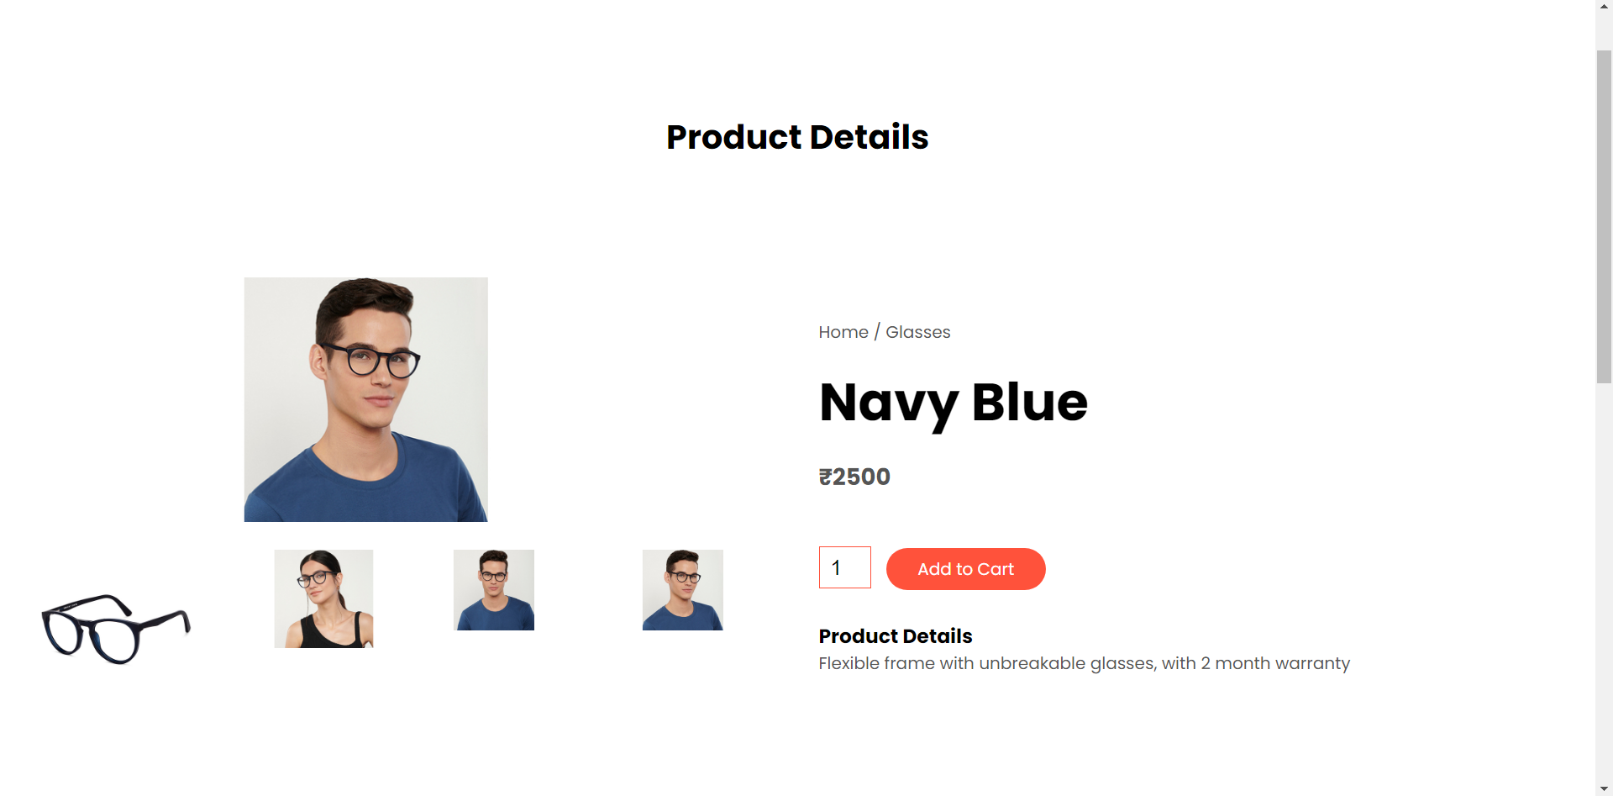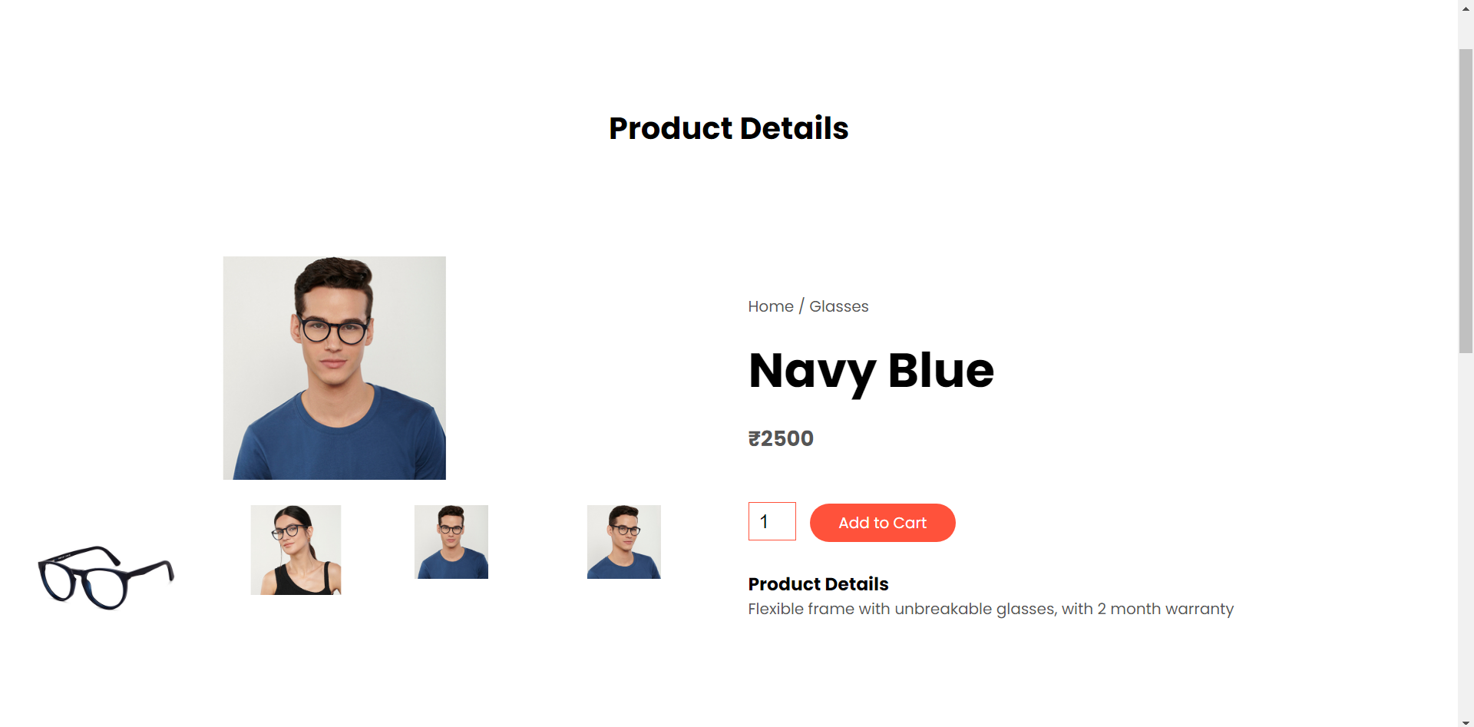

**Cart Page**

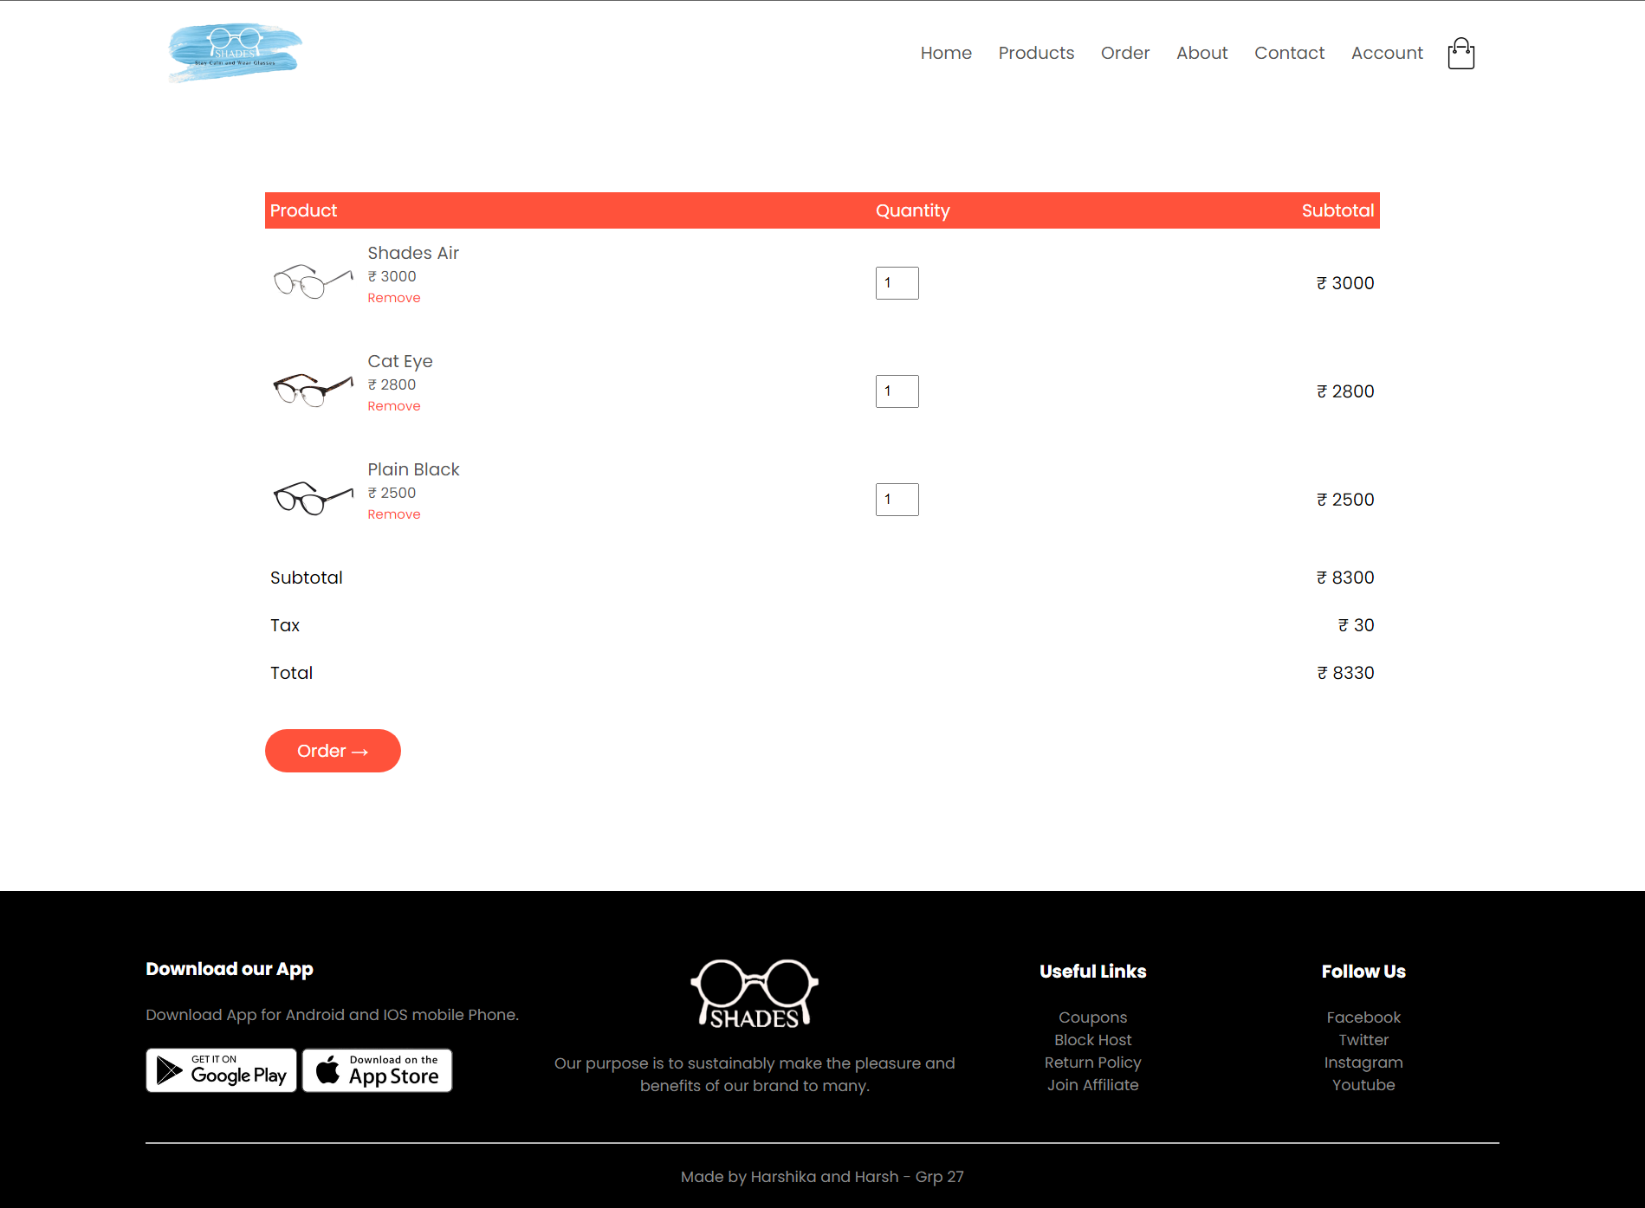

**Order**

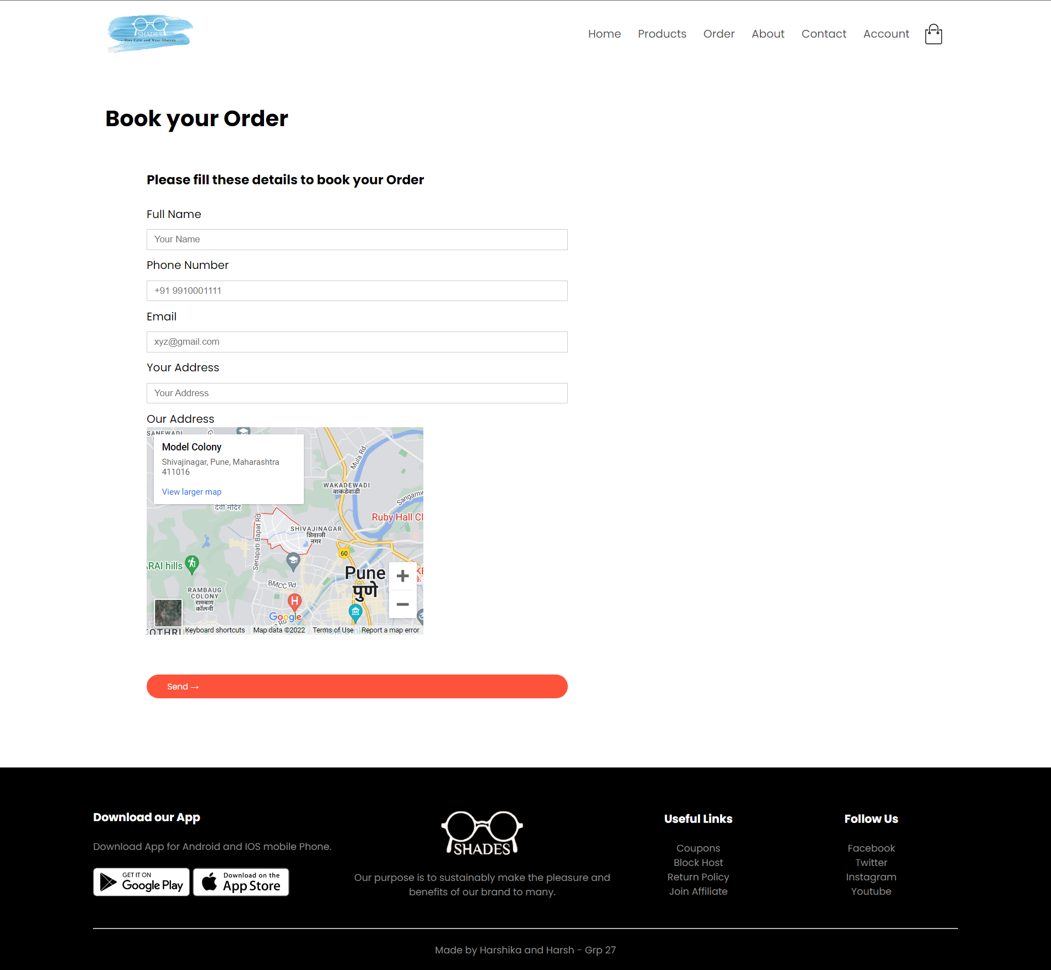

**About Us Page**

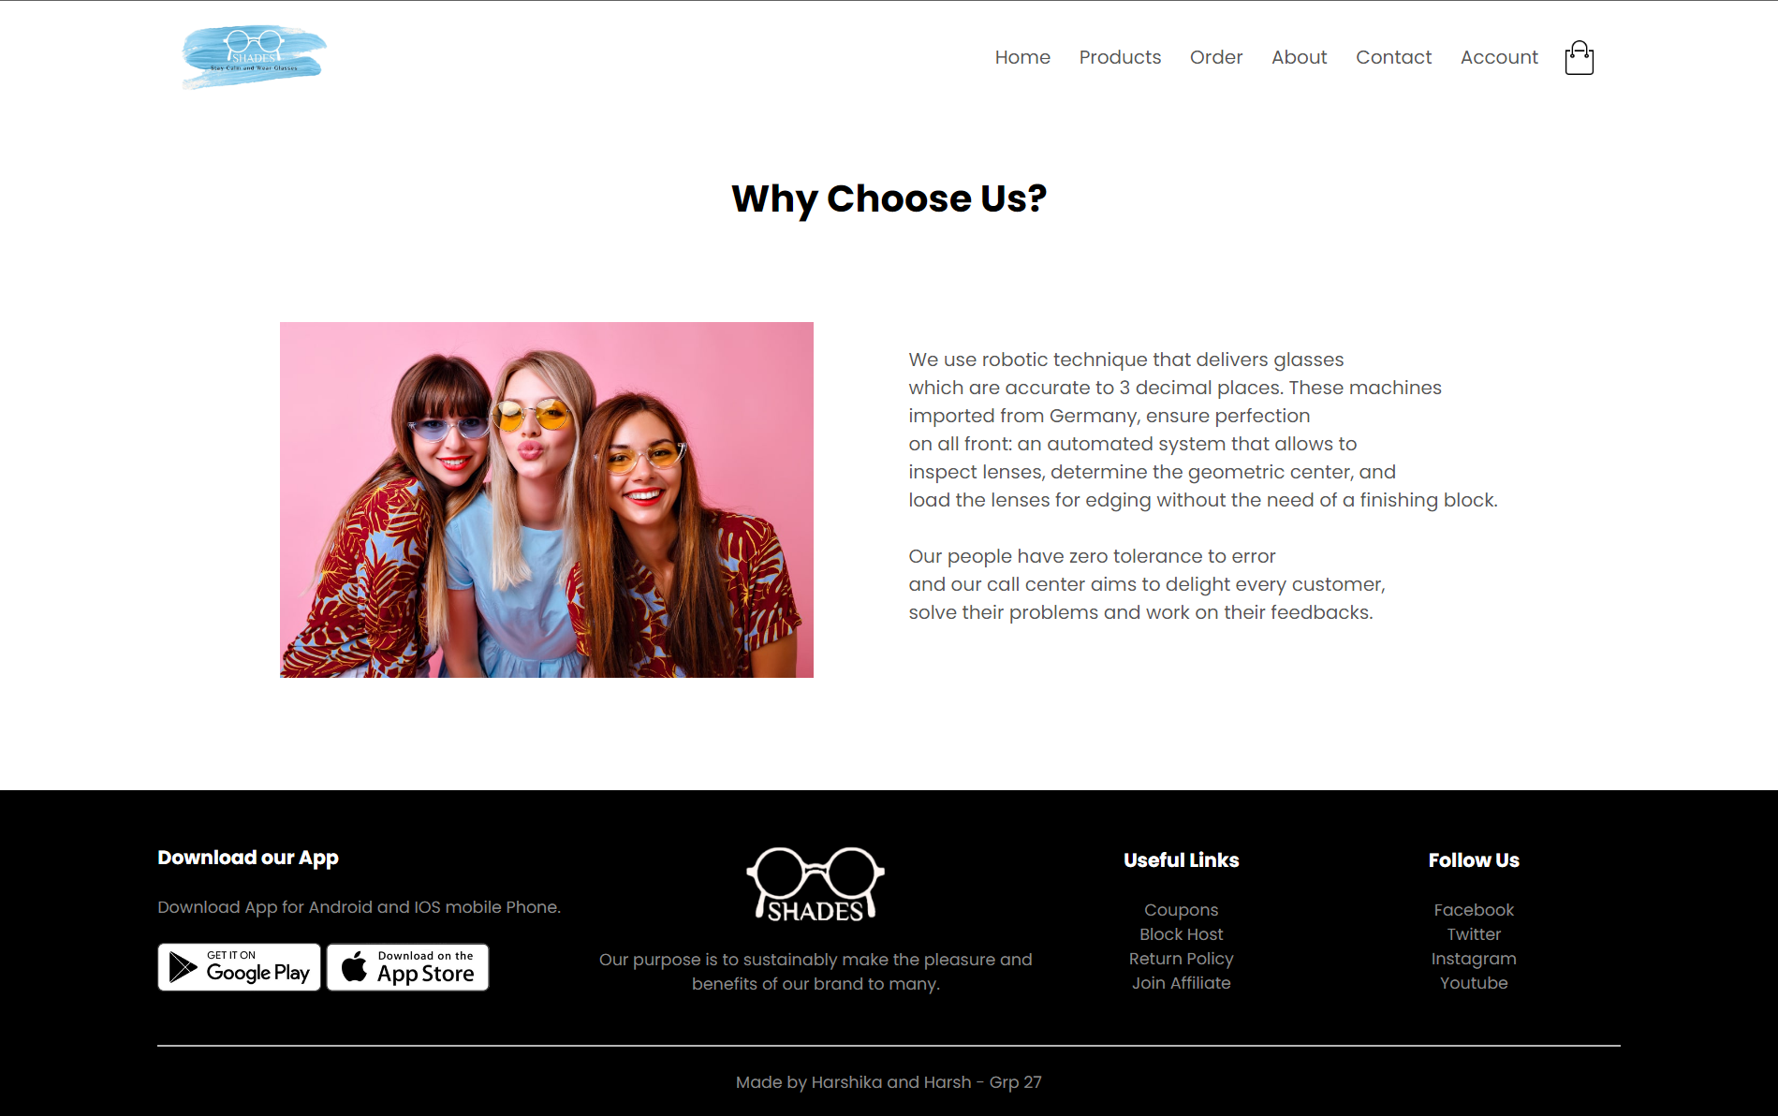

**Contact**

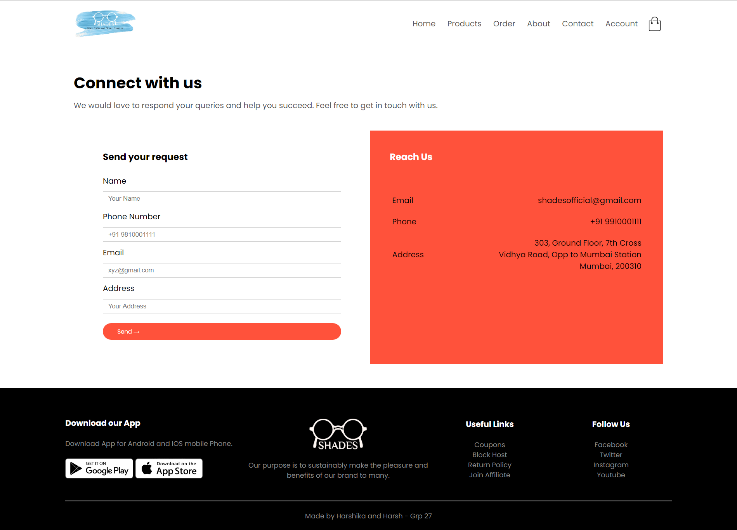

**Planning of the Website:**

**Sitemap:** The list of pages we have included and would include in the future are:

* A page that describes what the website is about about
* Blogs are essential needs of every company to describe what’s going on in the company and we want to include that
* Cart which every E-commerce website requires
* Contacts
* A home/landing page which will be the very first impression of the website
* Login/Register
* A home delivery system for frames and glasses from the local buisness
* Products

**Regular maintenance includes:**

* Editing existing content
* Adding content
* Fixing bugs and issues
* Dosing site backups
* Installing plugins

**References:** [https://www.lenskart.co](https://www.lenskart.com)